**Uncle and Auntie Pat (Chapter Two)**

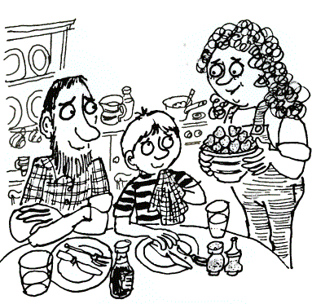

**Uncle-and-Auntie Pat soon made me feel at home. They cooked me a slap-up15 meal - heaps16 of scrambled egg, jacket potatoes and fresh vegetables followed by strawberries and cream.**

**Then they told me about Wishing Well Farm.**

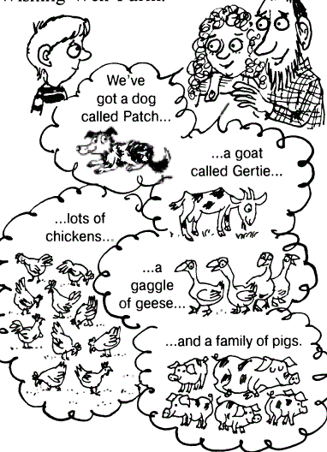

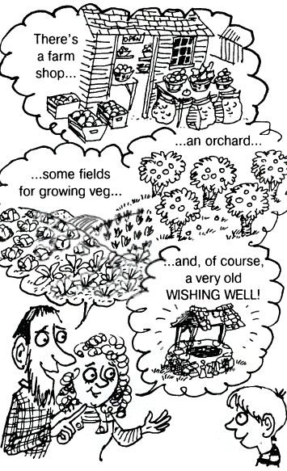

**They showed me to my room, up in the attic. I had a great view of the farmyard.**

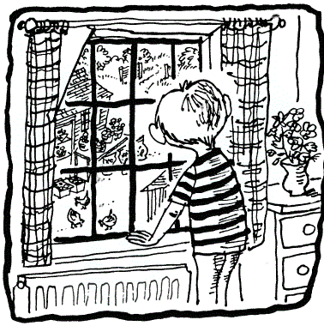

**I couldn't help noticing that the farm shop was very quiet. In fact, I didn't see a single customer all day.**

**That evening, when I came down to say goodnight, I overheard Uncle Pat talking with Auntie Pat. They both looked glum as they pored over their accounts.**

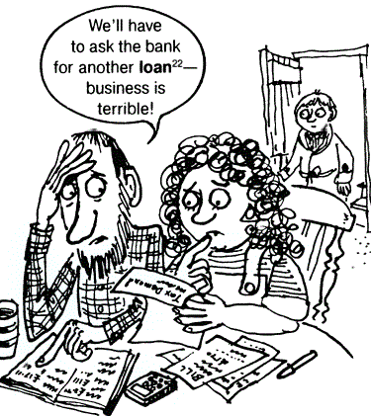

**I felt sad, but I slept soundly23 that night, and lost myself in dreams of the old wishing well.**

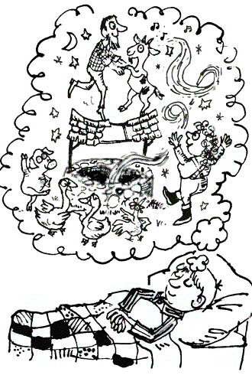

**Словарь:**

**slap-up — шикарный  
heap — куча  
couldn't help noticing — не мог не заметить  
overhear (overheard) — нечаянно услышать  
glum — мрачный  
роrе — сосредоточенно изучать  
account — счет  
loan — заем (в банке)  
soundly — крепко**